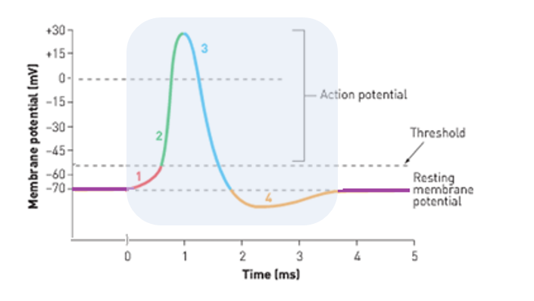**Action Potentials – Summary**

**Resting Membrane Potential (RMP):**

* This is when the neuron is not being stimulated

**Refractory Period:**

The shaded area on the graph shows the refractory period.   
  
The refractory period is the time in which the membrane cannot respond to new stimulus because the conditions for resting membrane potential have not been regained.

Ie: not at -70mV, Na+ greater outside membrane.

* Na+/K+ pump pumps 3 Na+ outside of the cell membrane and 2 K+ in.
* This makes the outside of the membrane positive.
* The inside is therefore relatively negative
* Because of this, the RMP is maintained at **-70mV**

**1: Initial Stimulation:**

* Initial stimulation opens some Na+ channels, and some Na+ moves in
* This changes the membrane potential so it is less negative.
* If it **does not** reach the threshold of -55mV, no action potential will occur and the RMP will return
* If the stimulus opens enough channels to reach the threshold of **-55mV**, depolarisation will be triggered.

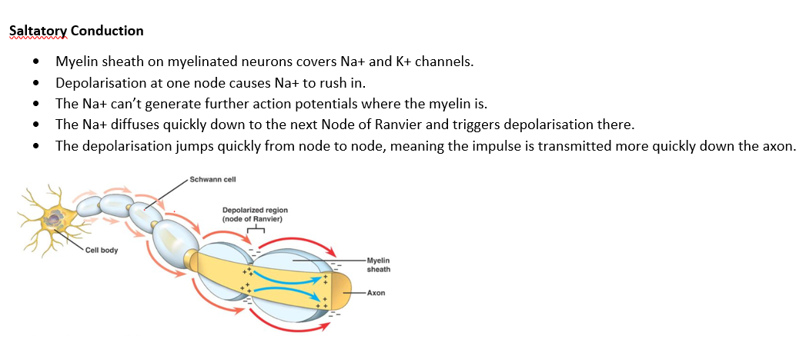**2: Depolarisation:**

**Saltatory Conduction**

* Only occurs if initial stimulation causes depolarisation beyond the threshold of -55mV
* If -55mV threshold is reached, gated Na+ channels open
* Na+ floods into the cell, causing the membrane potential to become positive (around +30mV)

**3: Repolarisation:**

* Occurs at peak of positive membrane potential (around +30mV)
* Na+ channels close
* Gated K+ channels open
* K+ floods out of the cell
* Membrane potential falls, neutralises and then becomes negative again, back down to -70mV

**4: Hyperpolarisation**

* K+ channels remain open, and membrane potential becomes even more negative.
* This is called hyperpolarisation
* At this point, high levels of K+ outside of the cell and high levels of Na+ inside.
* This must be changed to get back to Resting Membrane Potential so the membrane is ready for future action potentials.

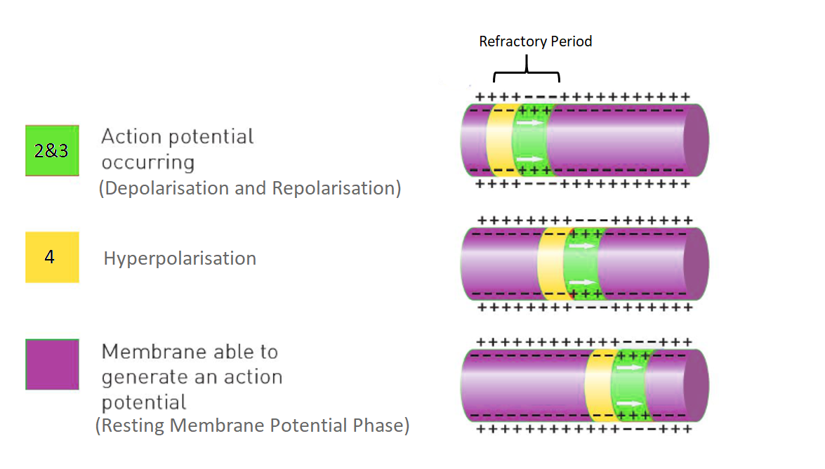**Return to Resting Membrane Potential**

* Gated K+ channels close. Na+ channels are still closed from repolarisation
* The Na+/K+ continues to work
* This returns Na+ to the outside of the membrane and K+ to inside.
* More Na+ is outside, so the inside is relatively negative
* The Resting Membrane Potential of -70mV is regained.

**Wave of Depolarisation along the Unmyelinated Axon:**

* As one section of the membrane depolarises, it stimulates the next section.
* The sequence of depolarisation, repolarisation, and hyperpolarisation moves along the axon in a wave.

Assembled by RB Feb 2020